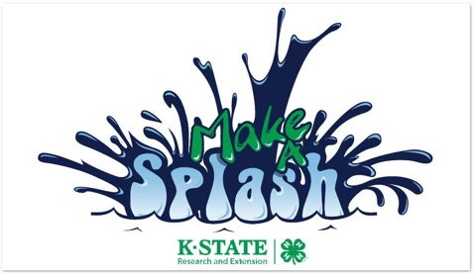
Discovery Days 2017

Highlights: | Are You Ready for Discovery Days? Put May 30 – June 2, 2017 on your calendar to be in Manhattan on the K-State campus. This year’s theme is “Make a Splash” Discovery Days offers classes and tours about 4-H projects, careers, hobbies, community service and more! You can also share your talents in the Talent Show. Are you ready to dance? Are you ready for some Call Hall ice cream? Are you ready for some great speakers and Discovery Days Night Live and all the other possibilities in your future?
Who Should  Register: | Discovery Days is open to all youth who are 13 to 18 years old by January 1, 2017. 4-H membership prior to Discovery Days is not required. All adults who will be participating in Discovery Days must also register.
Chaperones: | All adults have responsibilities throughout the conference. A designated adult chaperone is required for every 15 delegates. Chaperones must be at least 21 years of age and must be Volunteer Registered at their Local Extension Office.
Cost: | The registration fee is $230 which includes all meals, lodging, program expenses, insurance, a Discovery Days t-shirt and more! Some classes have additional fees to pay for supplies. For 2017 – if you would like to be housed in a suite (2-4 people sharing a bathroom) you can opt in for this, spaces are very limited this year and it will cost an additional $35.
Registration: | Please refer to your local Extension Office for payment and registration deadlines.  Registration opens on-line on March 1 at http://www.Kansas4-H.org. Registration closes and payment is due in your Extension Office no later than April 20, 2017. All on-line registrations are contingent upon your Extension Agent’s approval payment of fees by April 20.  Classes are filled on-line on a first come-first serve basis so do not wait until April 20 to register. Due to the complexity of class scheduling at Discovery Days, we do not take a wait list for classes.
Attire: | Dress for Discovery Days is casual, but not grubby. As at all 4-H events, offensive or inappropriate clothing will not be allowed. See “Delegate Guidelines” for additional information. Please refer to the Kansas 4-H Dress Code for additional guidelines on what is and is not appropriate while at Discovery Days
Web Site: | For more information and to register, go to: http://www.Kansas4-H.org

K-State Research and Extension is an equal opportunity provider and employer.

